Crossroads International Church Dr. Rick Griffith
Title
6 April 2014 Series on Revelation Message 17 of 20
NLT 66 Minutes
A Kingdom Removed
Revelation 17:1–19:10

Topic: Purity
Subject: Why should we reject the world and embrace God’s kingdom?
Complement: This world won’t last but Christ’s kingdom will.
Purpose: The listeners will
Meditation: God’s Holiness
Reading: 1 Pet. 1:13-21
Song: “This Kingdom”

Introduction

Interest: The pull of the world is strong!

No apostate wears a name badge.
Badge

However, many apostates have destroyed the Christian West.
Apostate

Kevin Swanson details this in his book Apostate.
Kevin

Who are these apostates? [List them.]
Who?

Why are they significant? [Read quote.]
Why?

What did they teach? [Read quotes.]
What?

Nietzsche is perhaps the classic example…
God is dead

Need: How are you doing with resisting the world and welcoming Christ?
How you resist?
The Revelation
3 slides

Subject: Why should we reject the world and embrace God’s kingdom?

Background: We have come to the point in Revelation where all the cycles of judgments have finished. However, the main worldly influence called Babylon still remains.
Sponsor
Preview
• Do?
T

Preview: Let’s see what will happen to that entity (Rev. 17) and what we should do about it (Rev. 18:1–19:10).

(So what will happen to the world’s most evil influence?)

I. This world’s key entity will fall in the Tribulation (Rev. 17).
3
• 1-2
Harlot
• MP
[The Antichrist will destroy “Babylon”—the key influence in the world system typified as a Harlot—in the second half of the Tribulation.]

End Times Babylon (the key influence in the world) is depicted as a prostitute controlling a beast (Antichrist as head of seven historical kingdoms) who himself controls ten rulers of his time (17:1-6).
5-6
4

Verses 1-6 describe Babylon as a beautiful but immoral prostitute.
Map
Dan

However, just as the OT city of Babylon fell, so End Times Babylon will fall.

We need to answer some key questions on this chapter:

Who are the major players in Revelation 17?
Players

[List all 10.]
• 1-10

There really are only 4 players!
4 circles

Identical symbols give only 4 entities.
4 identical

Who is the beast (17:3a) or eighth king (17:11)?
Rev 13

We saw the beast was Antichrist in chapter 13.
Who?

He was not Nero.
13:18
Future
7 kings

What is referred to by the seven kings = seven heads = seven hills (17:7, 9, 10)?
Not Nero
Nor Domitian
7 kingdoms
3 slides
Map of 10
• 10 • 8

These were not kings leading to Nero (AD 54-68).

These were not kings leading to Domitian (AD 81-96).

These were seven historical kingdoms from Egypt to Rome’s Caesars, plus a reunited Roman Empire in the future as the 7th king and Antichrist heading the final Gentile world kingdom as the 8th king.
EU
Stamp
Post WWII

What are the ten horns (17:3c, 7, 16) or ten kings (17:12-13)?

These are associated with the beast (Antichrist) as contemporaries (17:12).

Since they rule the world with him, they must be heads of 10 areas of the world.
Controls

Who or what is the Harlot (17:1) or Babylon (17:5) that is the “great city” (17:18)?
Who is Harlot?

She is an entity that will control the beast initially but then will be conquered and destroyed by Antichrist.
Controlled

Babylon the Harlot has had many identifications:
1/3s
World
Views
Fire

The World System

No one could mourn the demise of the world system from afar since they are part of it.

How could the world system break into three geographical sections?

A Religion
Religion

Islam
Islam

Catholicism

Astrology

One-World Religion

Apostate Church in Rome
Catholicism
Astrology
One-World Religion
Apostate Church

WCC
WCC
URI

URI

A City
City
Literal City

Babylon

Rome
Rome
Jerusalem

Jerusalem

A Nation = USA
USA

Antichrist will destroy End Times Babylon when he heads a confederacy of ten regions in the second half of the Tribulation (17:7-18).
7 heads & 10 horns

Seven kingdoms from Egypt to a revived Roman Empire will precede worldwide rule by Antichrist as the eighth king who controls ten world regions (17:7-14).
7 Kingdoms
Rides

Initial control of Antichrist by Babylon the prostitute will be reversed and Antichrist will destroy her in one hour by fire (17:15-18).
Killed
MPI
(Why reject the world and embrace God’s kingdom?)

II. The world’s key influence will be replaced with Christ’s kingdom (18:1–19:10).
MPII
[The reason readers should leave Babylon is because remorse on earth and rejoicing in heaven over Babylon's fall must occur before Christ establishes His own kingdom.]

Heaven will announce the fall of Babylon to encourage believers to leave her (18:1-8).
2b-3
Come out
3 slides
1-2a

She will grow rich through demonic power yet still fall (17:1-3).

Believers, therefore, should avoid her lure and “come out of her” (17:4).

The earth will mourn over Babylon’s fall because its businessmen can longer profit from the system's wealth (18:9-24).

They will be blind from seeing God’s hand in Babylon’s ruin (18:9-19).
9-10
Merchants
Earth Mourns

Yet heaven will see this as God’s judgment (18:20).
19:1-2
Fire
Quick
4 slides

Babylon will fall quickly (18:21-24).

Heaven will rejoice over Babylon’s fall and the Church will celebrate union with Christ just before he returns to set up his kingdom (19:1-10).

Heaven will rejoice over Babylon’s fall because the destruction of the evil empire allows Christ to replace it with a righteous kingdom (19:1-6).
19:3

The Church's final stage of being united with Christ, symbolized by the marriage feast of the Lamb with His bride, will anticipate Christ’s imminent return (19:7-10).
Union
4 slides

(Why reject the world and embrace God’s kingdom?)

Conclusion
MI
WCC
URI
Babylon
1/3s

This world won’t last but Christ’s kingdom will (MI).
Not last!

The reason readers should leave End Times Babylon—the key influence in the world—is because remorse on earth and rejoicing in heaven over Babylon's fall must occur before Christ establishes His own kingdom (EI).
MPII
MPI
Last!

The world’s key entity will fall… but it will be replaced with Christ’s kingdom!

Exhortation: There is only one command in these 2.5 chapters: “Come out of her” (18:4)!
Come out

In what sense do you need to “Come out of her” (18:4)?

As part of the bride, how can you make yourself ready?

Jeremiah told his people to “come out” or Jerusalem.

The author of Hebrews commanded the same.
Bride
Jeremiah 24
Hebrews 13

How can you “come out of her”?
How Come out?

Your eyes must see only what is pure.
• Eyes

Your ears should listen to only what builds you up.
• Ears

Your lips should speak only what is worthy of Christ.
• Lips
• Hands

Your hands should work diligently for him.

Your feet must lead only where Jesus would go.
• Feet
Armor

Maybe you need to review your armor and make sure it is all on. Read Ephesians 6 on your own.

Prayer
Prayer

Preliminary Questions

Verses Questions

Context: What did the author record just prior to this passage?

The final wrath of the bowl judgments (Rev. 15–16) happens right at the end of the Tribulation.

Now chapters 17–18 record what happens to the “Babylon” of that time period.

Purpose: Why is this passage in the Bible?

We will see in Revelation 19 that Jesus will return to set up his kingdom in chapter 20.

However, all other kingdoms must be removed before Christ can reign. Revelation 17–18 records the destruction of the most powerful entity on earth at the time.

Background: What historical context helps us understand this passage?

The city of Babylon sets the background for these chapters. The author assumes that we know it as the source of religious apostasy going all the way back to the false worship of Nimrod in Genesis 10:9-10.

The city of Babylon is the first city noted in Scripture, having been built by Nimrod (Gen. 10:10). It is also the origin of false teaching about God as Nimrod invented mother and son worship (later adopted by Egyptian and other religions, including Catholicism). After the city achieved prominence under King Nebuchadnezzar who destroyed Jerusalem (605-586 BC), Babylon was conquered by Persia in 539 BC and has lain virtually desolate for centuries.

Questions

Who or what is the Harlot (17:1) or Babylon (17:5) that is the “great city” (17:18)?

Who is the beast (17:3a) or eighth king (17:11)?

What is referred to by the seven kings = seven heads = seven hills (17:7, 9, 10)?

What are the ten horns (17:3c, 7, 16) or ten kings (17:12-13)?

Tentative Subject/Complement Statements

Text

Possible Illustrations

Text

Possible Applications

Text

      - (17:1–19:10) The fall of the world system (or USA? See pages 409-413) and the responses of remorse on earth and rejoicing in heaven encourage readers that this “Babylon” will be removed before Christ establishes His own kingdom.

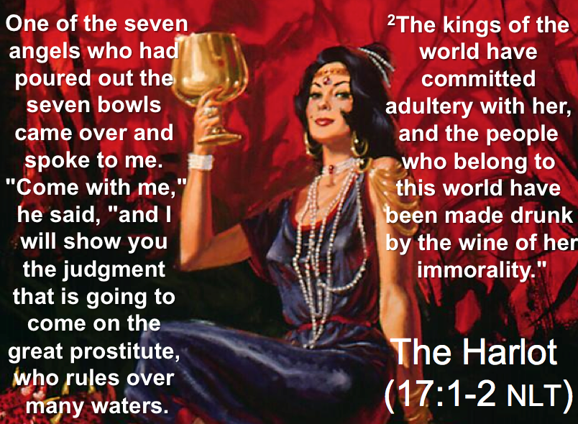

        - (17:1–18:8) The fall of the religious and commercial world system is detailed to encourage readers that it will be gone before Christ installs His own kingdom.

          - (Ch. 17) The fall of the religious world system, symbolized by the Harlot, Babylon the Great, comes after Antichrist is worshiped in the middle of the Tribulation.
            - (17:1-6) The fall of the religious world order is symbolized by a prostitute on a beast with seven heads and ten horns who adulterates with false doctrine and is named the Great Harlot, Babylon the Great.

            - (17:7-18) The symbols represent the apostate world church and a ten nation confederacy headed by Antichrist, who replaces this church with self-worship in the middle of the Tribulation (cf. Dan. 9:27).

          - (18:1-8) The fall of the world’s commercial system demonstrates Christ's superiority over this system and the need for it to be removed before He sets up His kingdom.

Continued on page 414 after the Revelation 17–18 excursus …

What is the Babylon of Revelation 17–18?
An Evaluation of Various Views
Introduction
  - The city of Babylon is the first city noted in Scripture, having been built by Nimrod (Gen. 10:10). It is also the origin of false teaching about God as Nimrod invented mother and son worship (later adopted by Egyptian and other religions, including Catholicism). After the city achieved prominence under King Nebuchadnezzar who destroyed Jerusalem (605-586 BC), Babylon was conquered by Persia in 539 BC and has lain virtually desolate for centuries.
  - One key issue is whether the 539 BC fall of the city fulfilled prophecies that the city would never again be inhabited (Isa. 13:20; cf. Jer. 50:23, 39-40; 51:37). This is important because if the prophecy is yet unfulfilled, then Babylon will still be rebuilt and then destroyed entirely.
  - With this brief background, Revelation 17–18 describes in detail the destruction of a world-powerful entity under the image of a harlot riding a beast. Often this has been called “End Times Babylon” by seeing the adjective “Mystery" (17:5) as part of the title. However, a better translation is: "This mysterious title was found on her head: BABYLON…" In the broadest sense this entity has three main dimensions: political, economic, and religious.
  - Major Players of Revelation 17–18
    - The Prostitute called Babylon (17:1-6)
    - The Waters (17:1, 15)
    - The Beast (17:3a, 7-8, 11)
    - The 7 Heads (17:3b, 7)
    - The 10 Horns (17:3c, 7, 12-13, 16)
    - The 7 Hills (17:9)
    - The 7 Kings (17:10)
    - The Great City reigning over the earth (17:18)
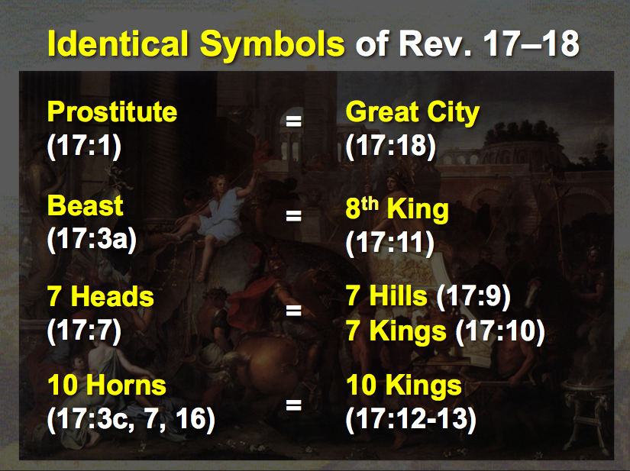

  - Characteristics
    - She is guilty of religious apostasy or idolatry that contaminates the world since the image of a prostitute is used of her (17:1a, 5; cf. 14:8). The harlot in Scripture sometimes depicts one who has strayed from her religious moorings in a “spiritual adultery” (e.g., Hosea 4:10-12). However, it also depicts the idolatry of nations that had never trusted in the Lord in the first place, such as Nineveh (Nah. 3:1, 4), Tyre (Isa. 23:15-17), and Babylon (Jer. 23:8-9).
      - Her blasphemy indicates her heretical stance (17:3).
      - She is filled with abominations (17:4-5).
      - Her spiritual association stems from the city of Babylon (17:5), which was the original center of false worship.
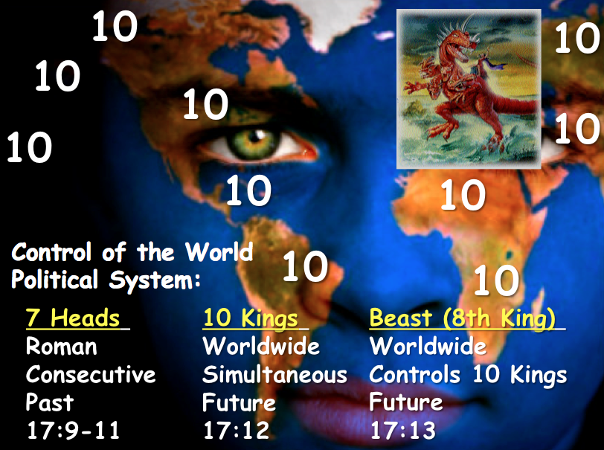
    - She has a world influence politically shown in her sitting on many waters (17:1b), which is a figure for many “peoples, multitudes, nations, and languages” (17:15), indicating an ecumenical nature. The breadth of her authority is over both the rulers and common people in the earth (17:2).
    - She initially controls the Antichrist since she rides the beast (17:3). The beast is a world ruler called the Antichrist (cf. Rev. 13:1-10) who himself controls two political entities: one comprised of seven nations and another of ten countries (17:3, 9, 12).

End Times Babylon (Prostitute)
(17:1–19:2)

later destroyed by beast (17:16)
at first
sits on (17:3)

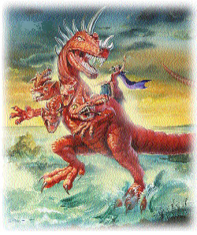
Scarlet Beast
• 7 Heads
• 10 Horns
(17:3,12)
rules over (17:2)

desires to rule over (17:17)

Kings of the Earth
(17:2)

All Peoples of the Earth
(17:2, 15)

    - She is extremely wealthy seen in her precious gems, clothes, metals (17:4) and numerous other products (18:3, 11-16, 23).

    - She persecutes the people of God (17:6; 18:24).

    - She associates with Rome in that she “sits” on seven hills (17:9). Given that Rome is known from ancient times as a city built upon seven hills, this confirms that the Babylon of Revelation 17-18 has a link with Rome, the kingdom “that is” in power during John’s time of writing (17:10).

    - She will be completely destroyed by the Antichrist and his ten-nation confederacy (17:16a) by fire (17:16b; 18:8) in only one hour (18:10, 17, 19).

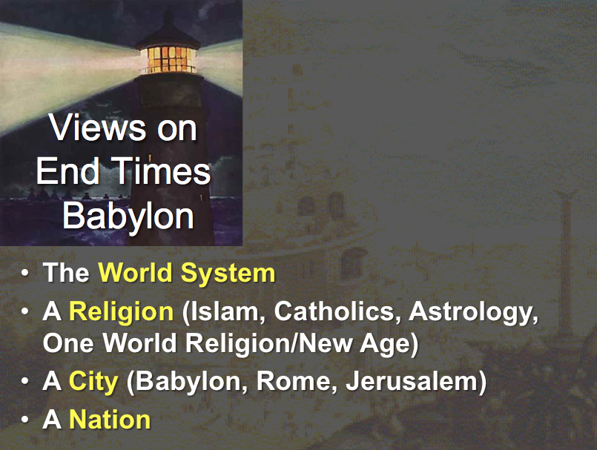

The Identity of End Times Babylon
  - World System (Political, Economic, and Religious)
    - Support
      - The worldwide influence of End Times Babylon could indicate that this entity is the world system itself that is organized against God (17:2).
      - All of the present kingdoms of the world must be removed before Christ sets up His own kingdom (20:1-6).

    - Problems
      - Reference to End Times Babylon as a city (17:18; 18:21) which influences Rome (17:9) refers to an entity that is smaller than the world system as a whole.
      - The destruction of End Times Babylon will be lamented by unbelieving political rulers (18:9-10), businessmen (18:11-16), and sailors (18:17-19). Since these mourners would be part of the world system themselves, they wouldn't be able to lament the destruction of the world system from afar.
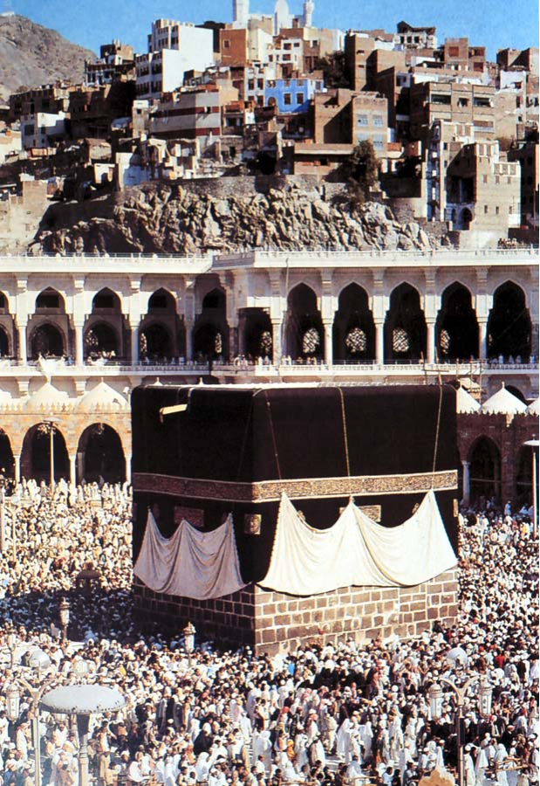
  - Religions
    - Islam
      - Support
        - Islam has been a great persecutor of the church (17:6).
        - Immorality is prevalent in Islam in respect to its polygamy and rape.
        - Islam has recently become a wealthy religion due to the vast Mid-East oil reserves and control of OPEC.
      - Problems
        - Though some Mid-East sheiks are vastly affluent, Muslims in general are not wealthy (17:4).
        - Immorality within Islam seems to not be any more common than in other institutions and religions.
        - While Islam through its association with OPEC has increased say in the world, these entities are not presently controlling a ten-nation confederacy (beast) or Rome.
    - Roman Catholicism
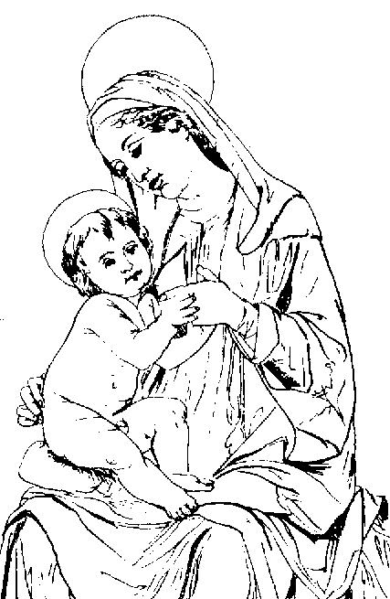
      - Support
        - Babylon was the source of false worship. In fact, much of Catholicism has come from Babylon—mother and son worship in particular. Add to this parallels in obelisks, relics, pilgrimages, indulgences, purgatory, pontiffs, celibate priests, transubstantiation, and both the Easter and Winter Festival.
        - Rome, with its seven hills, is the center of Catholicism (17:9).
      - Problems
        - Even though the RCC derives many of it teachings from Babylonian mystery religion, this does not equate the two entities.
        - The seven-hilled city and End Times Babylon are not the same entity since the woman rides the beast with these seven heads/hills (17:3, 7).
        - Italy has one of the weakest currencies in the world today, so it seems unlikely that the Vatican will achieve the economic envy of the planet.
        - While Catholicism is wealthy, it is overall in decline.
    - Astrology
      - Support
        - The prominence of worshipping the stars is well known as horoscopes appear in every major newspaper and increasingly on the Internet.
        - Ancient Babylon was known for its emphases on astronomy and astrology, so the association with End Times Babylon would be consistent.
        - End Times Babylon is a home for demons (18:2), which describes the satanic associations of astrology.

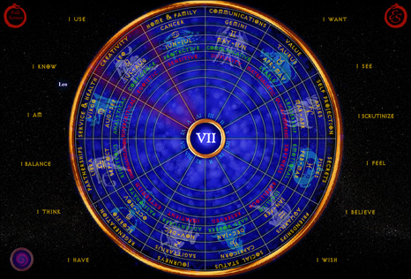
      - Problems
        - It seems unlikely that politicians, merchants and sailors would lament the demise of astrology (18:9-20).
        - “Babylon” being a home for demons (18:2) and destroyed by fire (17:16; 18:8) better indicates a physical location more than a religion or philosophy.
        - No musicians, businessmen, or marriages better indicates a place (18:21-24).
    - One-World Religion
      - Apostate Church Centered in Rome
        - Support
          - End Times Babylon is a city with great influence (17:18; 18:18, 21). Rome has had this kind of influence both then and now through the RCC.
          - The harlot has a place of authority over “peoples, and multitudes, and nations, and tongues” (17:15), so she rules the entire world beyond the bounds of the Roman Empire politically. This could be said of the RCC and apostate church.
          - The association with the seven hills (17:9) is Roman, but the ten nation Roman confederacy destroys End Times Babylon (17:12), thus showing that they are not one and the same.
          - Rome could be destroyed in an hour (18:10, 19).
          - The Apostate Church has absorbed many demonic influences (18:2).
        - Problems
          - The Apostate Church does not have the organized wealth characteristic of this Babylon (18:9, 11-13).
          - End Times Babylon is a limited geographical entity that has a worldwide influence, seen in its quick destruction (18:10, 19), marriages (18:23), and the fact that people will see its destruction from afar (18:9).
      - World Council of Churches
        - Support
          - The WCC became an entity to unite various religious systems in 1948.
          - This view reflects the compromise of truth that is characteristic of the entity being deemed to be "Babylon" (17:5).
        - Problems
          - The WCC influence increasingly decreases rather than increases.
          - End Times Babylon is repeatedly referred to as a city (17:18; 18:18, 21).

  - United Religions Organization (including New Age Movement)
    - Support
      - The diverse elements of “Babylon” (17:1, 15) also make up the UR.
      - The UR includes members of every religion but evangelical Christians.

    - Problems
      - The UR has yet to become a great influence in the world.
      - End Times Babylon is often called a city (17:18; 18:18, 21).
  - Cities
    - Babylon, Iraq
      - Support
        - The natural reading of "Babylon" is to take it at face value, meaning the city of Babylon.
        - Although Babylon today is still largely in ruins, it has been in a process of rebuilding by Saddam Hussein since the mid-1980s.
        - John specifically said that End Times Babylon is a city (Rev. 17:18).
      - Problems
        - John referred to this Babylon as a "Mystery," which probably implies that the literal city of Babylon is not meant.
        - It would be incredible, if not impossible, for even a rebuilt city of Babylon to attain the worldwide wealth and prominence to be the End Times Babylon. Present-day Iraq is virtually economically bankrupt and unlikely to rebuild Babylon to be more than just a tourist site.
        - The city referred to in Revelation 17:18 is indeed a city, but this city seems to be Rome more than Babylon: "The woman you saw is the great city that rules over the kings of the earth." Since Rome ruled the Roman Empire when John wrote this book, it is the more likely candidate than Babylon.
    - Babylon, Iraq in Revelation 18 but Catholicism (papal Rome) in Revelation 17.
      - Support
        - In Revelation 17 Babylon is a woman; in chapter 18 she is a city.
        - In Revelation 17 she is End Times Babylon; in Rev. 18 she is simply a city.
        - In chapter 17 Babylon is destroyed by the ten kings, probably in the middle of the Tribulation period; in chapter 18 these same kings lament over the destruction of literal Babylon, which is destroyed at the end of the Tribulation period, or when the Lord appears.
        - In chapter 17 Babylon is drunk with the blood of “saints and martyrs of Jesus” (17:6). In chapter 18 Babylon is drunk with the blood of the prophets and saints and all them that were slain upon the earth (18:24). The inclusiveness of Babylon’s drunkenness indicates she is a different thing than End Times Babylon in chapter 17. There we have papal Rome; here we have the total world of evil wrapped up in one city.
        - The destruction of the city is a sudden thing. The phrase “in one hour” occurs several times in Revelation 18. This destruction is like that of Sodom and Gomorrah. There is some evidence that “End Times Babylon” (chapter 17) is destroyed over some length of time. But literal Babylon “in one hour.”
        - Jeremiah’s commands to “flee her” (Jer. 50:8; 51:6, 9) were not directed to the people of old Babylon, since many of them did not obey (e.g., Daniel). It is directed, therefore, to the people of the end-time.
        - Some of the expressions adopted by John in Revelation 18 are taken from the description of old Babylon by Isaiah and Jeremiah. Why? Because they all refer to the same literal, restored Babylon of the end-time.
        - The particular sin of Babylon in chapter 17 is spiritual fornication; of Babylon in chapter 18, evil commercialism. This agrees with Zechariah 5:8 where wickedness is personified as a woman.

      - Problems
        - It is not true that in Revelation 17 Babylon is only a woman and in chapter 18 she is a city, for "the woman that you saw is the great city…" (17:18). The two images are thus interchangeable. Also, the Babylon of chapter 18 is called a prostitute again later in 19:2.
        - As noted in the introduction, the word "mystery" is likely not part of the title at all. Since elsewhere the title is simply "Babylon" (18:2, 10, 21) so the entity probably does not have "mystery" in the title at all.
        - The kings who lament Babylon's destruction (18:9) are not said to be the same kings as those comprising the ten horns (17:7). Also, given that this entire account (Rev. 17–18) appears after the bowl judgments at the end of the Tribulation (Rev. 16), the chronology of the book of Revelation shows End Times Babylon to be destroyed at the end of the Tribulation too.
        - The supposed contrasts between whom Babylon persecuted in the two chapters are forced. In both chapters she tormented saints (17:6; 18:20, 24). That prophets and apostles are noted in 18:20, 24 whereas martyrs ("those who bore testimony" NIV) are noted in 17:6 is not a contrast as much as inclusive of both.
        - Those teaching this combined papal/Iraq view do not give any support that "End Times Babylon" (deemed papal Rome of Rev. 17) is not sudden. In fact, the only time reference in chapter 17 is the same period as chapter 18. The time in which the beast shares power with the ten-nation confederacy is also "one hour" (17:12), which occurs just prior to the return of Christ (17:14; 19:19), probably after the hour-long destruction of Babylon (18:10, 17, 19).
        - Even if Jeremiah’s commands to leave Babylon apply only to the end-time city, this still would not warrant changing the identity of the Babylon of Revelation 17 to another entity in Revelation 18.
        - John's use of the prophetic language of Isaiah and Jeremiah does not equate the two Babylons. John elsewhere employs prophetic language in a heightened sense. For example, in Isaiah 65:20 the "new heavens and new earth" is where most people live beyond 100, which must be the millennium since death still exists; however, John employs new meaning to this same phrase by declaring that death is eradicated (Rev. 21:4).
        - Spiritual fornication (Rev. 17) is not contrasted with evil commercialism (Rev. 18), yielding separate entities. While the emphasis of chapter 18 is indeed trade, spiritual sin is also noted in chapter 18 with Babylon's association with demons (18:2), evil spirits (18:2), adulteries (18:3, 9; pornei,aj is the same word as in 17:2, 4), and her "magic spell" (18:23). Similarly, her wealth is noted in 17:4.
        - The account flows naturally from one chapter to the next, so a change in referent would be very confusing; thus, it is unlikely that the Babylon of Revelation 17 is different than the Babylon of Revelation 18.
    - Rome
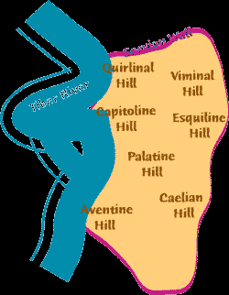
      - Support
        - "The woman you saw is the great city that rules over the kings of the earth" (Rev. 17:18) and Rome ruled the Roman Empire when John wrote this book.
        - Rome also was built upon seven hills (Rev. 17:9).
      - Problems
        - While Rome was the most influential city when John wrote, this End Times Babylon is the most powerful entity during the Tribulation when the prophecy will be fulfilled.
        - The seven hills and kings relate to the horns on the beast (Rev. 17:7-9), not to the woman who rides the beast (17:3). These two entities should remain distinct.
    - Jerusalem
      - Support
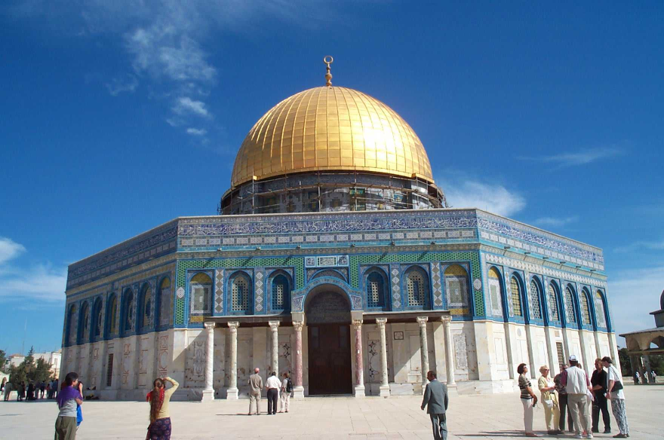
        - Jerusalem definitely fits into God's prophetic program for the end-times (cf. Zech. 14:1-5). In fact, the Tribulation period is called the "time of Jacob's wrath" (Jer. 30:7), indicating suffering for Jews and Israel.
        - The woman "sits on" (controls) seven heads (kings) which indicates power over Rome (17:9). Jerusalem's present control over Catholicism is evident in its jurisdiction over the many Roman Catholic churches throughout Israel.
        - Jerusalem has killed many of the saints and prophets of God (17:6).
      - Problems
        - While Jerusalem is prominent in prophecy, its worldwide influence occurs only in the millennium (Isa. 2) rather than the Tribulation period (which is the context for Rev. 17–18).
        - Whereas the text indicates the woman controlling Rome, the opposite was the case in John's day and in our own. Also, though modern Israel controls the Catholic sites in her domain, she has little if anything to say about Catholicism worldwide.
  - USA
    - Support (arguments from Chan Kai Lok)
      - Babylon must be a nation since no single city in the world reigns over the earth (17:18) and a "city" is a nation in biblical symbolism.
        - The New Jerusalem is a city (22:14, 19) but also a country/nation (Heb. 11:13-16).
        - The New Jerusalem is a city (22:14, 19) but also the Bride of Christ (21:2, 10), the latter also being designated a nation (1 Pet. 2:9).
        - Contrasts in the text abound between End Times Babylon (an unholy city/nation, Rev. 17–18) and the New Jerusalem (a holy city/nation/Bride of Christ, Rev. 21–22).
      - The US is Symbolized by a Woman (17:1-7, 18)
        - The key symbol of the US is the woman of the Statue of Liberty in New York Harbor.
        - America is the birthplace of modern feminism that has swept the globe.
      - The US is a Prostitute in the Spiritual Realm (17:1, 15-16; 19:2)—Since the biblical meaning of adultery is to forsake one's spiritual roots, the US qualifies well in this respect as it has abandoned its Christian heritage established by the Pilgrims.
      - The US is a Great Trading Centre (18:12-13)—End Times Babylon will be known around the world for its commerce.
        - The US is the largest business and financial hub in the world.
        - Wall Street is the largest stock market worldwide.
        - The US is the key player within the World Trade Organization.
        - US firms produce more goods overseas than any nation.
        - American trade spans the two major oceans in every item imaginable: precious metals and jewels (18:12a), clothing fashions and luxury items (18:12b), wheat and meat production, along with other foods (18:13a), and "the bodies and souls of men" (human trade in prostitution, drug trafficking, and pornography, 18:13b).
      - The US is Rich and Enriches Many Great Men (18:3, 14, 23).
        - No country or institution even begins to match the wealth of the US, with its abundance of cars, food, goods, and multiplied luxuries.
        - The US dollar is the standard trading currency on the globe.
        - Former poor nations have grown rich through US investment (e.g., Singapore, China)—even previous enemies of the US (e.g., Japan, Germany).
      - The US Controls Many Nations (17:1, 15).
        - The global dominance of America has increased dramatically with the fall of the USSR, leaving the US as the sole "Super Power" nation.
        - Washington's voice in the UN is preeminent.
        - Some nations cannot act without US approval (e.g., Israel).
        - American democracy is being embraced by the world increasingly.
      - The US Could Be Destroyed by Russia’s Nukes (17:3).
        - Whether the scarlet beast is Russia or the G7 and EC or some other entity, the US exercises more control over them all than does any other entity.
        - In any case, the Beast will destroy the Woman in one hour (18:8, 17, 19) by fire (17:16; 18:8-9). Even the destruction of a city by conventional fire takes several days (e.g., Great Chicago Fire, San Francisco Earthquake and Fire of 1906), so consumption by fire in only one hour almost inevitably must mean nuclear warfare. Russia has the greatest capacity to inflict this type of damage.
      - The US is Hedonistic and Other Nations Copy Her (18:3, 5).
        - The US continually boasts that it is protecting American interests globally.
        - Americans worship sex, material things, sports, entertainment, and pleasure—all of which are idols. The blatant idolatry of the TV show “American Idol” is mimicked around the world.
        - US-sponsored trends are copied worldwide (fast food, clothing, music, pornography, drugs, scientific breakthroughs, skateboards, etc.).
      - The US is Glorified and Lives in Great Comfort (18:7).
        - What nation or institution has the world's admiration more than the US?
        - Glory has been accrued to the US more than any nation in numerous areas: space technology, scientific discoveries, the most Nobel Prize winners, the most inventions, and the attraction of the best brains in the world.
        - The US is obsessed with comfort. More Americans are overweight than any other country. Homes have all the latest conveniences at bargain prices. Even Christians readily admit that they "church shop" until "we find a place that is comfortable."
      - The US is Occultic (17:5; 18:2-3).
        - The US association with ancient Babylon takes many forms.
          - Babylonian mystery religion is duplicated in the Catholic church in mother and son worship, celibate priests, purgatory, celebration of Nimrod's birthday on December 25, etc. This teaching has been marketed to the world from Catholic American missionaries and, in the case of Christmas, US concerns for business profits.
          - Babylonian occultism is the root of numerous US secret societies (e.g., Gnostics, FreeMasons, Rosicrucians, Theosophists, Neo Nazis, etc.).
        - The End Times Babylon is "a home for demons and… every evil spirit" (18:2) and the US Bill of Rights safeguard of freedom of religion has enabled the country to have more cults than any nation (over 5000!). Similarly, every major US city has a satanic church.
        - Secular humanism is now the protected national religion while prayer and anything Christian is outlawed in schools and many public arenas.
      - The US is Immoral and Abominable
        - American immorality gives it the highest rates in the world for prostitution, rape, sex outside of marriage, divorce, abortion (over 55 million!), child abuse, drug use, and venereal disease.
        - The US has the distinction as the world's most influential marketer of media filth (all protected by America's "free speech" law).
      - The US Deceives All Nations with Her Sorcery (18:23)—The Greek (farmakei,a pharmakeia) for the "sorcery" (KJV) or "magic spell" (NIV) of End Times Babylon may actually refer to drug use ("enchantment with drugs"), of which the US is the worst. This “sorcery, magic” (BDAG) may be drug induced.
      - The US Sits as a Queen, is No Widow, and Sees No Sorrow (18:7).
        - Babylon's claim, "I am not a widow" affirms that her men have not died on battlefields. Such was the case in recent wars the US has fought. During the Gulf War (January 17-February 28, 1991) General Norman Schwarzhkopf so overwhelmed Saddam Hussein's forces that the ground war lasted only five days. The enemy was defeated at about 1000 enemy forces killed for each American soldier, and most of them were killed by friendly fire! The USA’s overwhelming victory over the Taliban in Afghanistan was similar, as was the Iraq War that toppled Saddam Hussein.
        - Babylon's claim, "I will never mourn (see no sorrow)" results from such war success. No army can better make this claim than the US Army.
        - Given unequalled US military prowess, she sits as "queen" with increased credibility as the policeman and peacemaker of the world. In particular, US dominance over the Arab states and Russia are no longer in question.
        - Believing that the Cold War is over, the sale of many US bases by the Department of Defense has filled the coffers as well, just like a queen's.
      - The US has Killed the Prophets and Saints of God (17:6; 18:24).
        - At first this may not seem to be characteristic of the USA, which was founded upon freedom of conscience and has championed the cause of religious freedom worldwide. Tolerance of all viewpoints is the byword of the day.
        - Yet end-time Babylon is also guilty "of all who have been killed on the earth" (18:24). Since no entity is guilty of every murder worldwide, this obviously is an exaggeration for effect. What is meant is that Babylon is guilty of being a partaker of other people's sins in the sense that the Pharisees were partakers of the sins of their fathers against the prophets (Matt. 23:29-32; Luke 11:47-52).
        - In this sense the US is passively guilty of the blood of prophets and saints, for the US has abandoned its original commission of the Pilgrim days to witness for God. Instead, it approves of these sins in its midst: Satan worship, idolatry, drug trafficking, pornography, adultery, homosexuality, and the like.
        - In another sense, the USA is actively guilty of killing many saints, for the wholesale slaughter of 55 million unborn in this generation alone has murdered millions who would have grown up to serve as God's witnesses around the globe. The other countries of the world have followed the US lead in the abortion holocaust, killing untold millions of God's children.
    - Problems
      - Although the woman of the Statue of Liberty is one symbol of America, it is not the primary one. The national symbol of the US is the bald eagle.
      - Chan Kai Lok makes no attempt to prove that Russia is the beast of Revelation 13:1-10; 17:3f. He appeals rather to Revelation See’s book The Antichrist is Now Here! In fact, though Chan's book appeared in 1992, he refers to the Antichrist as "USSR"—two full years after the breakup of the USSR in 1990.
      - Chan has made numerous "prophetic" blunders. He predicted the economic collapse of the USA in 1992, the return of Mikhail Gorbachev to power in 1992, and the nuclear destruction of the USA by Russia in 1993.
      - Theological problems abound in the book. Dubious exegetical support is given to prove that the USA is the people of God or the "Joseph people" (descendants of Ephraim and Manasseh), questionable theological teachings are based on the numbers 13 and 17, adulterers are all deemed unsaved, Maitreya is claimed to be the demon behind the Antichrist (other demons are also "identified"), and the first three seals of Revelation 6 are incorrectly linked to events of 1990-1991.

Conclusion

No one can identify the Babylon of Revelation 17–18 with certainty. However, for the reasons cited in this study, it would seem that Babylon is neither a city (Rome, Jerusalem, or Babylon, Iraq) nor a confederation of nations (which confuses Babylon with the beast and its ten horns and seven heads).

While one cannot be certain, the most plausible identification is the most powerful and influential nation in the world: the United States of America. This study does not endorse the sensationalistic features and date-setting errors of Dr. Chan Kai Lok. Nevertheless, a comparison of the characteristics of this end-time Babylon with America leaves no better option at the present time.

Of course, nothing excludes a more powerful entity than the US arising in the future, so one cannot be certain of the US as this entity. Until God reveals Babylon's identity without question, Christians should not be looking for Babylon but rather should be accomplishing the commission given to us by Jesus Christ to bring the gospel to the world.
Charles Ryrie on End Times Babylon

Charles C. Ryrie has his own summary of the nature of End Times Babylon:
The Characteristics of End Times Babylon.

Certain characteristics of Babylon of Revelation 17 are specified.

(1) She is a harlot (v. 1). This obviously means she is unfaithful. She professes to be a system of religious truth and is in reality one of falsehood. This is confirmed by the name she assumes—“End Times Babylon” (v. 5).

(2) She is ecumenical (vv. 1,15). She sits upon many waters which are explained as being “peoples, and multitudes, and nations, and tongues.”

(3) She unites church and state under her sway (vv. 2-3). By granting her favors to the kings of the earth she is able to dominate the beast (v. 3) who is the head of the western confederation of nations (vv. 12-13) and whose dominion coincides with that of the whore (13:7).

(4) She is a “whited sepulcher” (v. 4). Outwardly she has great grandeur but inwardly she is filled with filthiness.

(5) She is a federation (v. 5). Her name is “The Mother of Harlots” which seems to indicate that she is a sort of mother church incorporating a number of equally false religious systems. It is because of this designation that many understand that the apostate church will be meshed with the Roman Catholic system, but not restricted to it.

(6) She is a persecutor of the saints (v. 6).

(7) She is destroyed completely by the beast (v. 16). This probably occurs at the middle of the tribulation period. It is described as a decisive and complete overthrow of the power of the apostate religious system (Charles C. Ryrie, “Apostasy in the Church,” Bibliotheca Sacra 121 [Jan-March 1964]: 51-52).

The ten nation Roman confederacy receives power along with the beast or Antichrist (17:12), thus showing that they are not one and the same.

Outline continued from page 396…

(c) (18:9–19:10) The remorse on earth for Babylon's fall is contrasted with the rejoicing in heaven that readers may understand the fall from God's perspective and rejoice at the soon coming of Christ.

            - (18:9-24) The earth mourns over Babylon’s fall because its businessmen can longer profit from the system's commercial enterprises.

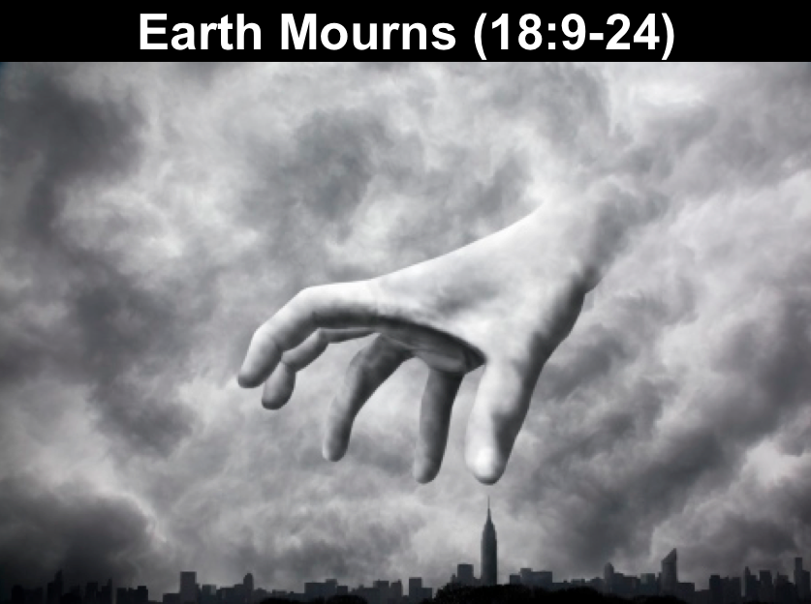

            - (19:1-10) Heaven rejoices over Babylon’s fall and the completed Church celebrates her union with Christ in anticipation of His imminent Second Coming to set up a righteous kingdom.

          - (19:1-6) Heaven rejoices over Babylon’s fall because the destruction of the evil empire allows Christ to replace it with a righteous kingdom.

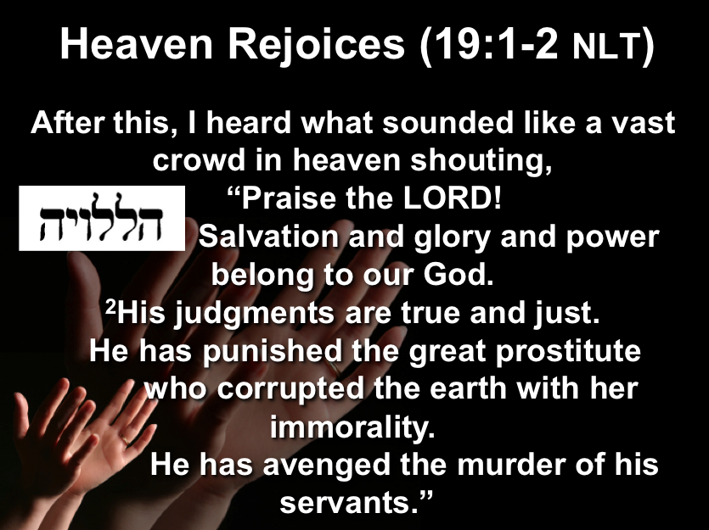
          - (19:7-10) The Church's final stage of being united with Christ, symbolized by the marriage feast of the Lamb with His bride, is celebrated in anticipation of the imminent Second Coming of Christ.

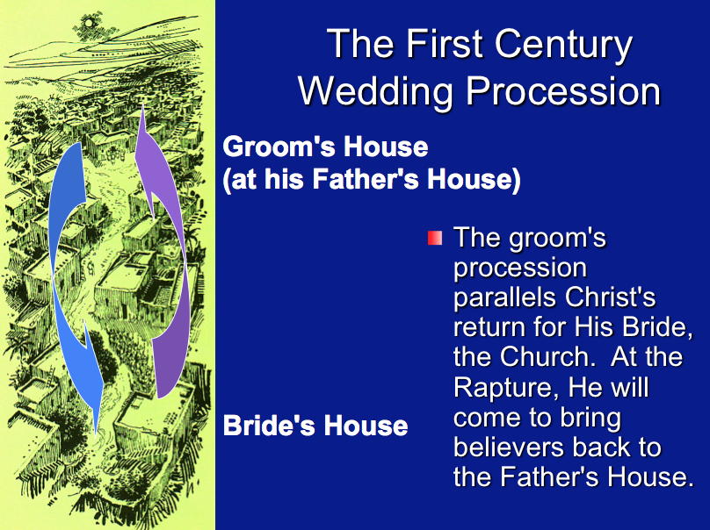

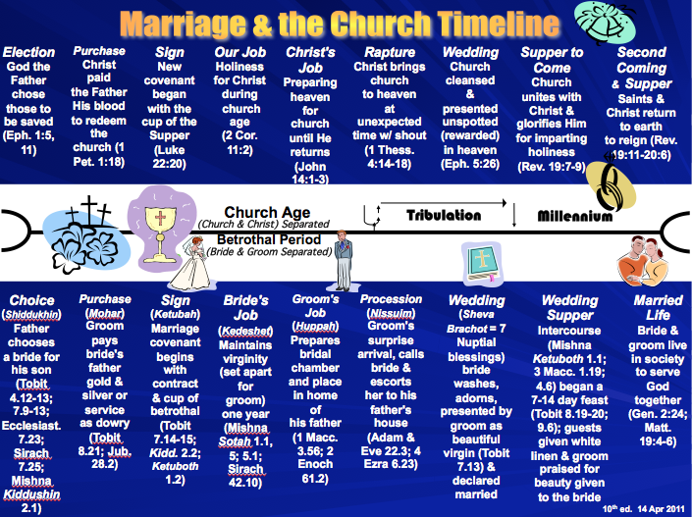

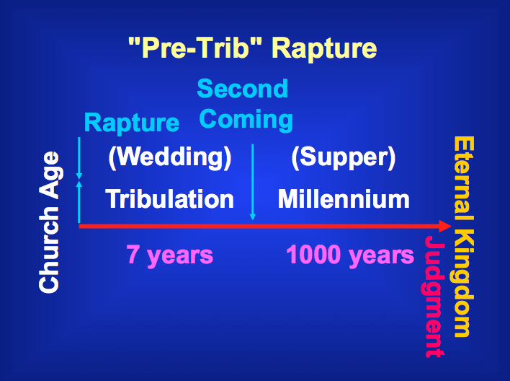

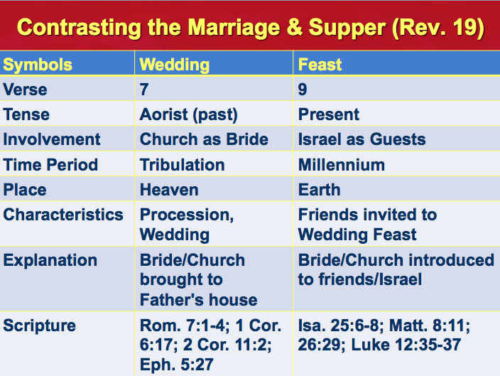

Outline continued from the end of major point “A” on page 415 that concluded with 19:10…

A Kingdom Removed
Revelation 17–18

Exegetical Outline (Steps 2-3)

Exegetical Idea: The reason readers should leave End Times Babylon—the key influence in the world—is because remorse on earth and rejoicing in heaven over Babylon's fall must occur before Christ establishes His own kingdom (17:1–19:10).

I. The end of “Babylon” (the key influence in the world system typified as a Harlot) is that Antichrist will destroy her in the second half of the Tribulation (Rev. 17).

End Times Babylon (the key influence in the world) is depicted as a prostitute controlling a beast (Antichrist as head of seven historical kingdoms) who himself controls ten rulers of his time (17:1-6).

Antichrist will destroy End Times Babylon when he heads a confederacy of ten regions in the second half of the Tribulation (17:7-18; cf. Dan. 9:27).

Seven kingdoms from Egypt to a revived Roman Empire will precede worldwide rule by Antichrist as the eighth king who controls ten world regions (17:7-14).

Initial control of Antichrist by Babylon the prostitute will be reversed and Antichrist will destroy her in one hour by fire (17:15-18).

II. The reason readers should leave Babylon is because remorse on earth and rejoicing in heaven over Babylon's fall must occur before Christ establishes His own kingdom (18:1–19:10).

Heaven will announce the fall of Babylon to encourage believers to leave her (18:1-8).

The earth will mourn over Babylon’s fall because its businessmen can longer profit from the system's wealth (18:9-24).

Heaven will rejoice over Babylon’s fall and the Church will celebrate union with Christ just before he returns to set up his kingdom (19:1-10).

Heaven will rejoice over Babylon’s fall because the destruction of the evil empire allows Christ to replace it with a righteous kingdom (19:1-6).

The Church's final stage of being united with Christ, symbolized by the marriage feast of the Lamb with His bride, will anticipate Christ’s imminent return (19:7-10).

Purpose or Desired Listener Response (Step 4)
The listeners will

Homiletical Outline (Cyclical inductive form)

Introduction

Interest: The pull of the world is strong!

Need: How are you doing with resisting the world and welcoming Christ?

Subject: Why should we reject the world and embrace God’s kingdom?

Background: We have come to the point in Revelation where all the cycles of judgments have finished. However, the main worldly influence called Babylon still remains.

Preview: Let’s see what will happen to that entity (Rev. 17) and what we should do about it (Rev. 18:1–19:10).

(So what will happen to the most evil influence in the world?)

I. This world’s key entity will fall in the Tribulation (Rev. 17).

End Times Babylon (the key influence in the world) is depicted as a prostitute controlling a beast (Antichrist as head of seven historical kingdoms) who himself controls ten rulers of his time (17:1-6).

Antichrist will destroy End Times Babylon when he heads a confederacy of ten regions in the second half of the Tribulation (17:7-18).

Seven kingdoms from Egypt to a revived Roman Empire will precede worldwide rule by Antichrist as the eighth king who controls ten world regions (17:7-14).

Initial control of Antichrist by Babylon the prostitute will be reversed and Antichrist will destroy her in one hour by fire (17:15-18).

(Why reject the world and embrace God’s kingdom?)

II. The world’s key influence will be replaced with Christ’s kingdom (18:1–19:10).

Heaven will announce the fall of Babylon to encourage believers to leave her (18:1-8).

The earth will mourn over Babylon’s fall because its businessmen can longer profit from the system's wealth (18:9-24).

Heaven will rejoice over Babylon’s fall and the Church will celebrate union with Christ just before he returns to set up his kingdom (19:1-10).

Heaven will rejoice over Babylon’s fall because the destruction of the evil empire allows Christ to replace it with a righteous kingdom (19:1-6).

The Church's final stage of being united with Christ, symbolized by the marriage feast of the Lamb with His bride, will anticipate Christ’s imminent return (19:7-10).

(Why reject the world and embrace God’s kingdom?)

Conclusion

This world won’t last but Christ’s kingdom will (MI).

The reason readers should leave End Times Babylon—the key influence in the world—is because remorse on earth and rejoicing in heaven over Babylon's fall must occur before Christ establishes His own kingdom (EI).

Main Points

Exhortation: In what sense do you need to “Come out of her” (18:4)?

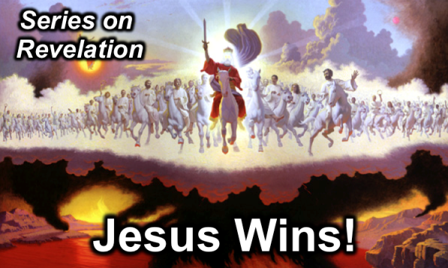
Rick Griffith
6 April 2014
Message 17 of 20

A Kingdom Removed
Revelation 17–18

Introduction

The pull of the world is strong!

Why should we _______________ the world and embrace God’s kingdom?

(So what will happen to the most evil influence in the world?)

I. This world’s key entity will _____________ in the Tribulation (Rev. 17).

End Times Babylon (the key influence in the world) is depicted as a prostitute controlling a beast (Antichrist as head of seven historical kingdoms) who himself controls ten rulers of his time (17:1-6).

Antichrist will destroy End Times Babylon when he heads a confederacy of ten regions in the second half of the Tribulation (17:7-18).

Seven kingdoms from Egypt to a revived Roman Empire will precede worldwide rule by Antichrist as the eighth king who controls ten world regions (17:7-14).

Initial control of Antichrist by Babylon the prostitute will be reversed and Antichrist will destroy her in one hour by fire (17:15-18).

(Why reject the world and embrace God’s kingdom?)

II. The world’s key influence will be _____________ with Christ’s kingdom (18:1–19:10).

Heaven will announce the fall of Babylon to encourage believers to leave her (18:1-8).

The earth will mourn over Babylon’s fall because its businessmen can longer profit from the system's wealth (18:9-24).

Heaven will rejoice over Babylon’s fall and the Church will celebrate union with Christ just before he returns to set up his kingdom (19:1-10).

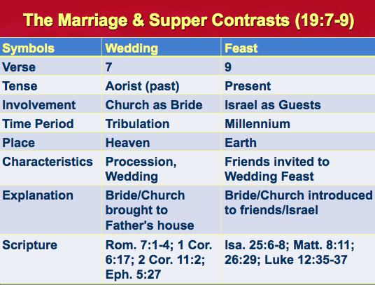
Heaven will rejoice over Babylon’s fall because the destruction of the evil empire allows Christ to replace it with a righteous kingdom (19:1-6).

The Church's final stage of being united with Christ, symbolized by the marriage feast of the Lamb with His bride, will anticipate Christ’s imminent return (19:7-10).

(Why reject the world and embrace God’s kingdom?)

Conclusion

This world won’t __________ but Christ’s kingdom will (Main Idea).

Exhortation: In what sense do you need to “come out of her” (18:4)?

Thought Questions:

- Read Revelation 17:1–19:10 aloud. List each key trait of the Harlot (Babylon) and give its meaning the best you can.

Trait (and verse) | Meaning

- How does the marriage and supper (19:6-9) fit into the context here?

- In what sense do you need to “come out of Babylon” in terms of your values? Your use of time? Your future plans?

Isaiah and Jeremiah both note that Babylon was to be destroyed literally, suddenly, and completely. Isaiah says: “And Babylon, the glory of kingdoms, the beauty of the Chaldeans’ pride, shall be as when God overthrew Sodom and Gomorrah. It shall never be inhabited, neither shall it be dwelt in from generation to generation: neither shall the Arabian pitch tent there; neither shall shepherds make their flocks to lie down there. But wild beasts of the desert shall lie there…” (Isa. 13:19-21). And Jeremiah says: “How is Babylon become a desolation among the nations!” (50:23); “Therefore the wild beasts of the desert with the wolves shall dwell there, and the ostriches shall dwell therein; and it shall no more be inhabited for ever; neither shall it be dwelt in from generation to generation. As when God overthrew Sodom and Gomorrah and the neighbor cities thereof, saith Jehovah, so shall no man dwell there, neither shall any son of man sojourn therein” (50:39, 40); “And Babylon shall become heaps, a dwelling-place for jackals, an astonishment, and a hissing, without inhabitant” (51:37). These authors argue that Babylon has yet to be rebuilt and destroyed: Richard Hayes McCartney, The City of the Antichrist: Babylon in Chaldea (New York: Revell, 1917); Charles Dyer, The Rise of Babylon (Wheaton: Tyndale, 1991). They point out that Babylon has never been without inhabitants so that the prophecy yet remains unfulfilled. In fact, in 331 Babylon received Alexander the Great with open arms. Though prophesied that Babylon’s stones will never be used to rebuild other Arab cities, many Arab villages and towns have been built from Babylonian stone, such as Seleucia, Ctesiphon, Al Modain, and Kufa (G. H. Pember, The Antichrist, Babylon, and the Coming of the Kingdom [London: Hodder and Stoughton, 2d. ed., 1888]).
NIV Study Bible text note on 17:5.
James M. McKeever, "Who is End Times Babylon?" END 151 (April 1991): 1-11 declares that a Muslim-OPEC partnership is in view; Ramon Bennett, Philistine: The Great Deception (Jerusalem: Arm of Salvation, 1995) declares that Islam is the greatest threat in the world today.
Most Reformers saw Catholics as End Times Babylon (e.g., John Calvin, Institutes of the Christian Religion, IV, 2:12); Ralph Woodrow, Babylon Mystery Religion (Riverside, CA: Woodrow Evan. Assoc., Inc., 1966, 1981), 7, 12.
See Alexander Hislop, The Two Babylons.
Hal Lindsey, The Late Great Planet Earth (Grand Rapids: Zondervan, 1970; reprint, Bantam, 1973), 103-23.
Paul Benware, Understanding End Times Prophecy: A Comprehensive Approach 2d ed. (Chicago: Moody, 1995, 2006), 309. John Walvoord sees this as likely “a world religion which could conceivably embrace all branches of Christianity—Roman, Greek Orthodox, and Protestant—as well as non-Christian religions” (“Revival of Rome,” Bibliotheca Sacra 126 [October-December 1969]: 325; “Revelation,” Bible Knowledge Commentary [Wheaton: SP Publication, 1983], 17:6 notes). An adaptation of this view is to see this one world apostate church as the sum of the RCC (Roman Catholic Church) and the WCC (World Council of Churches).
Rene Pache, “The Ecumenical Movement, Part 4: Moving Toward the Super-Church,” Bibliotheca Sacra 108 (April-June 1951): 201.
Tim LaHaye and Jerry B. Jenkins, Are Living in the End Times? (Wheaton, IL: Tyndale, 1999), 177-78; W. B. Howard, Endtime 8 (May/June 1998): 12-14.
W. Glyn Evans, “Will Babylon Be Restored?” 2 Parts. Bibliotheca Sacra 107 (July-September 1950): 335-42 and (October-December 1950): 481-87; Robert L. Thomas, Revelation 8–22: An Exegetical Commentary (Chicago: Moody, 1995), 279, 283, 288-89; Charles Dyer and Angela Elwell Hunt, The Rise of Babylon: Sign of the End Times (Wheaton: Tyndale, 1991), 158, 209-210. Arguing against the literal Babylon, Iraq is Homer Heater, Jr., “Do the Prophets Teach that Babylonia Will Be Built in the Eschaton?” Journal of the Evangelical Theological Society 41 (March 1998): 23-43.
Pember cites the first four arguments; the remaining arguments are from William R. Newell, The Revelation (Chicago: Scripture Press, 1935).
Robert Mounce, The Book of Revelation, NICNT (Grand Rapids: Eerdmans, 1977), 306-36. Arguing against Rome and in favor of Babylon, Iraq is Thomas, 289.
J. Massyngberde Ford, Revelation, Anchor Bible (Garden City, NY: Doubleday, 1975), 283-86.
David Wilkerson, Set the Trumpet to Thy Mouth (Lindale, TX: World Challenge, 1985), 3; Chan Kai Lock, Who is End Times Babylon? (Singapore: by the author, 1992), 3.
Chan identifies the 7 heads of the USSR beast as the 7 Warsaw Pact nations (East Germany, Poland, Czechoslovakia, Hungary, Romania, Bulgaria and Russia) and the 10 horns as the 10 Soviet republics of the Commonwealth of Independent States, or CIS (p. 13). Such a specific designation can only be speculated though.
See Ralph Woodrow, Babylon Mystery Religion (Riverside, CA: Woodrow Evan. Assoc., Inc., 1966, 1981); Frederick A. Tatford, Five Minutes to Midnight (London: Victory Press, 1980).
Dave Hunt, Peace, Prosperity and the Coming Holocaust (Eugene, OR: Harvest House, 1983).
Robert Young, Young's Analytical Concordance.
NIV Study Bible notes on Rev. 18:7.
Chan, 107.
Ibid., 140.
Chan, 107-8, 134, prophesies a nuclear destruction and pages 137, 145 specify the year as 1993.
Ibid., 28, 60.
Ibid., 29-39.
Ibid., 80, 115-34.
Ibid., 65.
Ibid., 139-45.

